**Sprint 4 Report**

**Plan-it**

**Team Rocket**

**12/1/19**

**Actions to Stop Doing:**

N/A: last Sprint.

**Actions to Start Doing:**

N/A: last Sprint.

**Actions to Keep Doing:**

N/A: last Sprint.

**Work Completed/ Not Completed:**

* Successfully improved main algorithm to adapt to the “type” of each activity.
* Successfully implemented unit tests, and fixed all major bugs across the system.
* Unable to set up the project with continuous integration due to time constraints.
* Unable to add user rating feature due to time constraints.
* Unable to add manual activity option due to time constraints.
* Unable to add user bookmark capability due to time constraints.

**Work Completion Rate:**

* User stories completed: 2
* Total ideal work hours: 34
* Total days in Sprint: 14
* Ideal work hours/day: 2.43
* Overall ideal work hours/day: 2.24
* User stories/day: 0.14
* Overall user stories/day: 0.199

Burndown Chart:

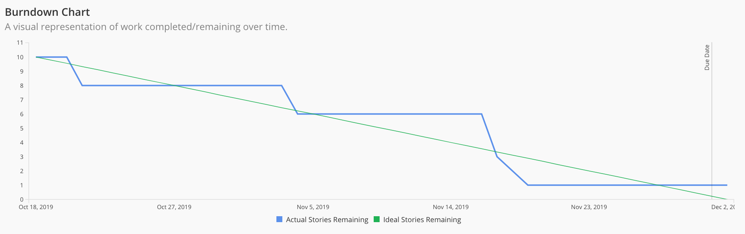

All User Stories Completed:

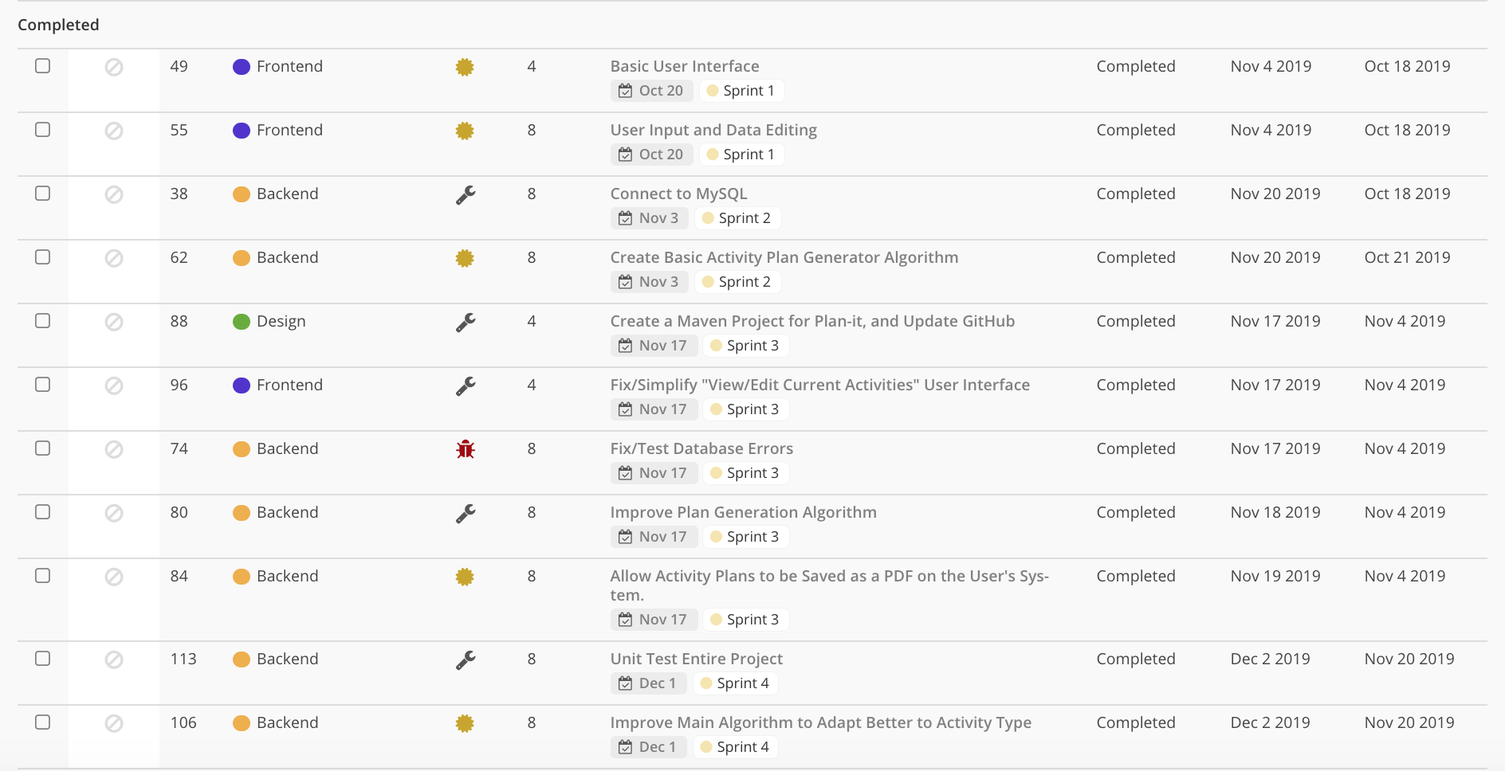

Cumulative Progress (Does not include Sprint 1):

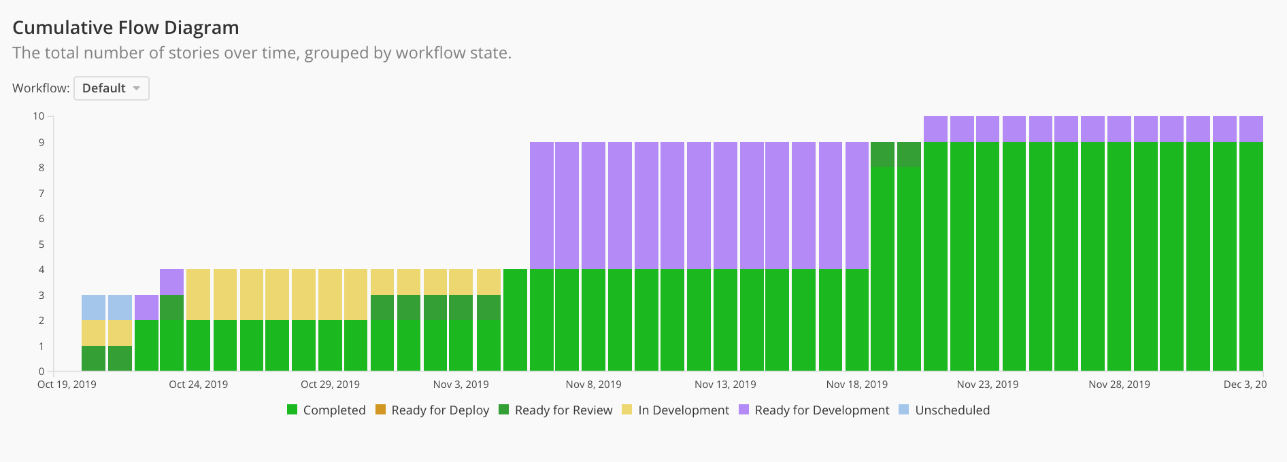

Velocity Chart (Does not include Sprint 1):

